1. Understand the data and the discrepancies associated with it.

* File type states ‘Microsoft Excel Comma Separated Values file’ i.e. csv, however contents are of type of ‘Microsoft Excel Worksheet’.

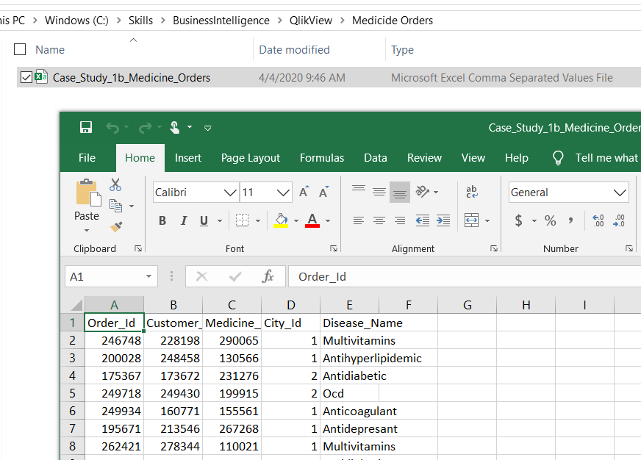

So, in QlikView File Wizard also not capturing details as expected.

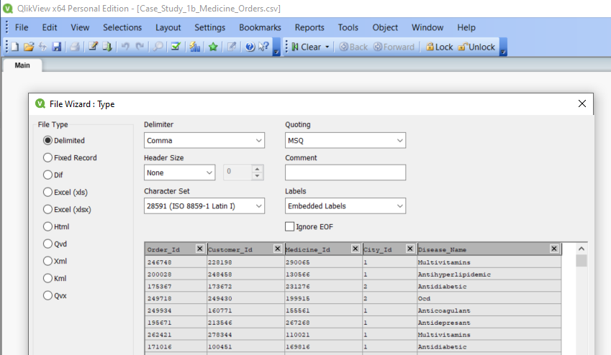

**Solution: Change File type and then import data in QlikView**

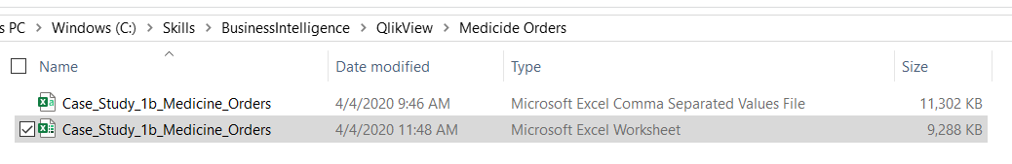

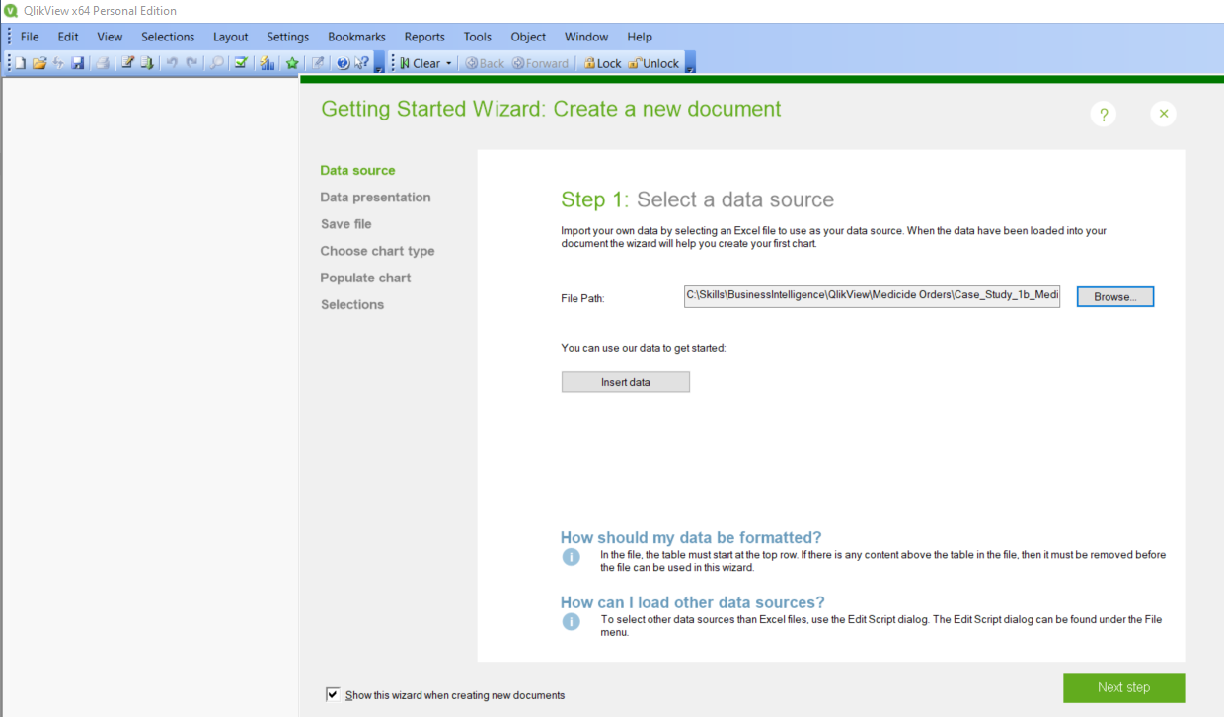

2. Analysis based on Disease_Name

a. Top 10 Disease

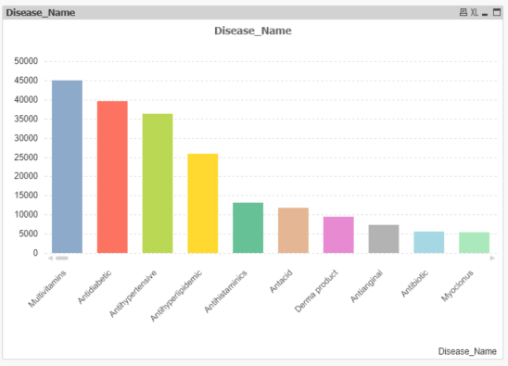

b. What % of orders were for “Multivitamin”

* **17.00%**

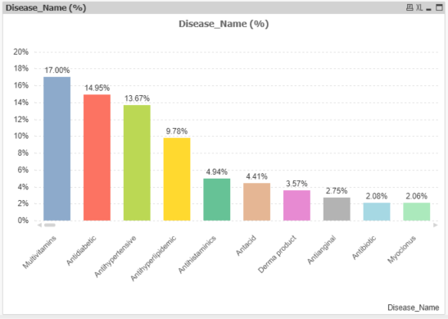

3. Analysis based on City_Id

a. Which city orders the most medicines and what can you infer from it?

* The City having ‘City_Id’ = 1, orders the most medicines. Below chart show number of medicines ordered by each City.

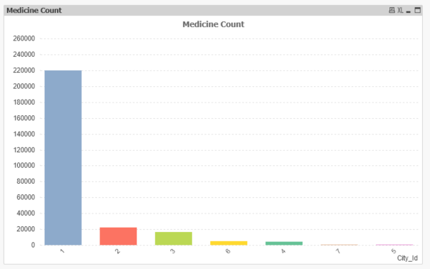

b. Which medicine is ordered most by the top city?

* Medicine having Medicine_Id = 250883 is ordered most by the top City (City_Id = 1)

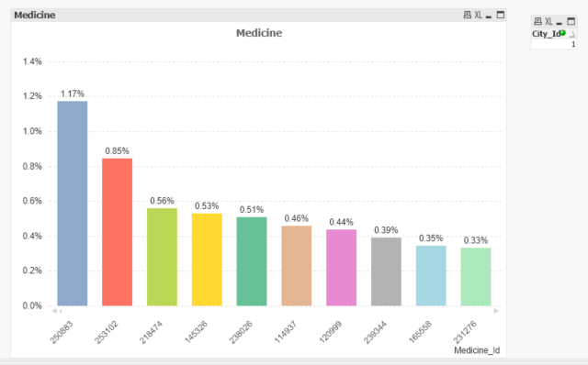

4. Identify top 10 repeat buyers per city

5. Based on top city identified in Q3-b, which customer orders the most and which is the medicine ordered.